The PA, UN, and Norway behind center named after terrorist murderer Dalal Mughrabi who led killing of 37 civilians, including 12 children
May 26, 2017
By: Itamar Marcus and Nan Jacques Zilberdik
Palestinian Media Watch
http://palwatch.org/main.aspx?fi=157&doc_id=21152

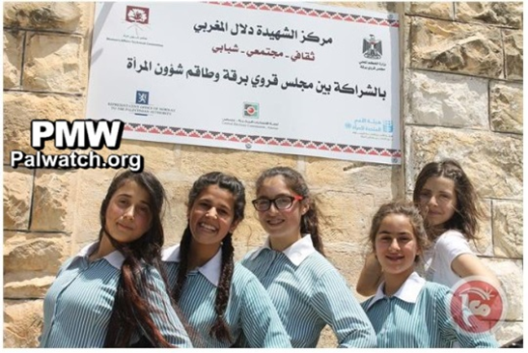
[Ma'an, independent Palestinian news agency, May 15, 2017]
Name sign on building includes logos of
- The PA Ministry of Local Government (upper right)
- UN Women (lower right)
- The Norwegian Representative Office to the PA (lower left)
Text on sign:
"Martyr Dalal Mughrabi Center
A cultural and social center and youth center
In partnership with the Burqa village council
and the Women's [Technical] Affairs Committee"
Purpose of the center:
"The center will focus especially on the history of the struggle of Martyr Dalal Mughrabi and on presenting it to the youth groups."
by Itamar Marcus and Nan Jacques Zilberdik
In another show of admiration for terrorist murderers and according to the Palestinian Authority's policy of presenting them as role models for Palestinian youth, the Palestinian NGO "Women's Technical Affairs Committee" (WTAC) has named a youth center for women after the terrorist murderer who led the most lethal attack in Israel's history.
The Dalal Mughrabi Center is a joint initiative of the NGO, the PA, the UN, and the Norwegian government! The center's name sign prominently includes the logos of:
- The PA Ministry of Local Government
- UN Women
- The Norwegian Representative Office to the PA
The center, which was inaugurated last week, is named after the terrorist who in 1978 led a group of terrorists who hijacked a bus and killed 37 Israelis, among them of these 12 children:
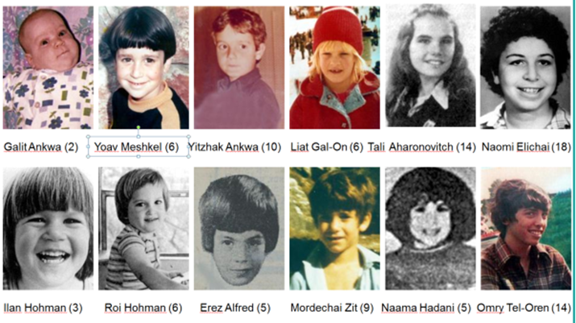
Worse still, it is not only the name that glorifies the terrorist murderer, the purpose of the center is to educate about her murderous terror attack to youth. At the inauguration of the center, which is situated in the village of Burqa in the Nablus district, a member of the village council, explained about the center's activities:
"Reem Hajje, a member of the village council, noted that the center will focus especially on the history of the struggle of Martyr Dalal Mughrabi and on presenting it to the youth groups, and that it constitutes the beginning of the launch of enrichment activities regarding the history of the Palestinian struggle."
[Ma'an, independent Palestinian news agency, May 15, 2017]
The Norwegian Representative Office describes its cultural activities with Palestinians on its website:
"The Norwegian Representative Office (NRO), along with Norwegian cultural institutions, are among the main cooperation partners in the culture sector in Palestine. The NRO culture program includes supporting cultural rights and increasing the capacity of the culture sector, through civil society organizations that can play the role as agents of change, in cooperation with the Ministry of Culture."
[Website of the Representative Office of Norway
to the Palestinian Authority, accessed May 25, 2017]
It would seem Norway expects the WTAC to "play the role as agents of change" - but one wonders which change that might be when the new center teaches youth that a terrorist murderer is a role model for women.
UN Women is listed on WTAC's website as a "partner," and NGO Monitor has documented that UN Women is a donor of the WATC.
Palestinian Media Watch has documented that the PA has turned Mughrabi into a role model for Palestinians. Among other things, it has named 3 schools after her, Abbas has named a computer center after her, and held a birthday celebration for her.
Palestinian Media Watch reports have led to debates in the Norwegian government about Norway's funding of the PA and the PA's practice of paying salaries to terrorists.
The following is a longer excerpt of the article reporting on the opening of the center named after terrorist murderer Dalal Mughrabi:
Headline: "The Women's [Technical] Affairs Committee inaugurated a women's center in Burqa"
"The Women's [Technical] Affairs Committee, today, Monday [May 15, 2017], inaugurated the Martyr Dalal Mughrabi Center (i.e., terrorist who led murder of 37, 12 of them children) in the village of Burqa in the Nablus district.
The renovation of this center and turning it into a place for the village's activities were carried out as part of an initiative of the Women's [Technical] Affairs Committee in partnership with female members of the village council. This building will be used to hold social activities and activities for women and youth...
Reem Hajje, a member of the village council, noted that the center will focus especially on the history of the struggle of Martyr Dalal Mughrabi and on presenting it to the youth groups, and that it constitutes the beginning of the launch of enrichment activities regarding the history of the Palestinian struggle.
The inauguration of the center on the 69th anniversary of the Nakba (i.e., "the catastrophe," Palestinian term for the establishment of the State of Israel) symbolizes the persistence in continuing on the path of struggle and honoring the Palestinian female and male fighters."
[Ma'an, independent Palestinian news agency, May 15, 2017]
The photo shows girls posing at the Dalal Mughrabi Center below a sign with the logo of the PA Ministry of Local Government (upper right), the logo of the WATC (upper left), the logo of UN Women - a UN organization for women - (lower right), the logo of the Norwegian Representative Office to the PA (lower left) and the logo of the Central Elections Commission - Palestine.
Text on sign:
"Martyr Dalal Mughrabi Center
A cultural and social center and youth center
In partnership with the Burqa village council and the Committee for Women's Affairs"
Dalal Mughrabi led the most lethal terror attack in Israel's history, known as the Coastal Road massacre, in 1978, when she and other Fatah terrorists hijacked a bus on Israel's Coastal Highway, murdering 37 civilians, 12 of them children, and wounding over 70.
Women's Technical Affairs Committee (WATC) - a Palestinian NGO committed to advocate Palestinian women's rights. WATC states on its website that many of its members are also members of the PLO but it does not seem as if the WATC itself is a member of the PLO. The website says WATC "embrace[s] a coalition of seven women's frameworks, represented in the Palestine Liberation Organization (PLO) and a number of women's centers and activists."

