At the U.N. Obama Promotes Human Wrongs Against Israel Instead of Human Rights

By Anne Bayefsky
September 16, 2010
Fox News
http://www.foxnews.com/opinion/2010/09/16/anne-bayefsky-human-rights-council-eileen-donahoe-israel-palestinian-authority/

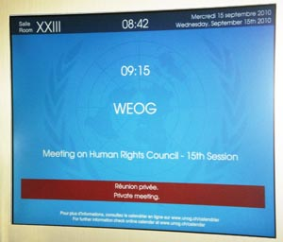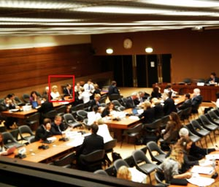
Palais des Nations, Geneva, Switzerland, Sep 15, 2010 U.S. Ambassador Donahoe and First Secretary Cassayre,
Geneva, September 15, 2010

Wednesday in Geneva during the current session of the U.N. Human Rights Council, the Obama administration became a willing participant in the U.N.'s imposition of an apartheid-style ban on representatives of the state of Israel. Despite the promises made by the administration that by joining the Council the United States would not become part of the problem, U.S. Ambassador to the Council Eileen Donahoe chose to attend and fully participate in a meeting that deliberately excluded anyone representing the Jewish state.

Israel is the only U.N. state not permitted to be a full member of any of the U.N.'s five regional groups. Throughout the Human Rights Council sessions, these groups hold key planning meetings in which countries negotiate and share important information behind closed doors. Even the Palestinian Authority, though not a state, is permitted into the Asian regional group. Israelis are allowed into the Western European and Others Group (WEOG) in some parts of the U.N. But WEOG members have chosen to exclude them totally in all of their meetings associated with the Human Rights Council. Rather than refusing to participate until such outrageous discrimination comes to an end, Obama administration representatives walked through the door slammed in the face of Israelis and made themselves comfortable.

While Israelis are left standing in the hall during the Council's regional group meetings, this week for the first time Libya took its seat as a full-fledged Council member. Other full voting members of the U.N.'s lead human rights body include such model citizens as Saudi Arabia, China, Cuba, Russia and Kyrgyzstan.

Joining the Human Rights Council was one of President Obama's first foreign policy decisions. He knew then – what is still true today – that the Council has adopted more resolutions and decisions condemning the state of Israel than all other 191 U.N. members combined. He knew that the permanent formal agenda of the Council includes one item to condemn Israel and one for the rest of the world.

But rather than refusing to lend legitimacy to a body with a deeply entrenched bias, the president chose to join and direct U.S. taxpayer dollars its way, claiming that he would be the Council's great reformer.

On Monday, writing in The New York Times, Ambassador Donahoe repeated the claim that U.S. engagement filled “a vacuum of leadership” and alleged that “the council is engaged in a serious self-reflection exercise for the purpose of improving its work and functioning with respect to its core mandate of protecting human rights.”

On the very same day as Donahoe's op-ed appeared, the 57 members of the Organization of the Islamic Conference (OIC) put the president in his place on any notion of reform. The OIC holds the balance of power at the Council, because the Council majority is composed of members from the African and Asian regional groups, and OIC countries form the majority in both the African and Asian groups.

Speaking Monday on behalf of the OIC, Pakistan declared: “the OIC…has always stressed that this is…not a ‘reform' exercise. It is our considered view that this intergovernmental process…should not reopen the lnstitution-building package [the June 2007 agreement which governs Council operations and adopted the agenda singling out Israel]…The Council is mandated to [do] nothing more but to fine-tune where required.”

The Obama administration's push to characterize its involvement with the Council as a success is a serious misstatement of the facts on many levels. For example, Donahoe claimed in The Times that “In June the United States co-led a cross-regional effort with 55 other nations to criticize the deplorable human rights situation in Iran…U.S. engagement at the Human Rights Council is working.”

That would be news to human rights victims in Iran. What actually occurred was that on June 15 the Norwegian Ambassador to the Council read a 171-second statement on Iran. She was interrupted 14 times, and the meeting was suspended in the middle of her statement for two hours. When the meeting resumed, Ambassador Bente Angell-Hansen felt compelled to omit the word “Iran” in several places from her original text and painfully read “We call on the *aforementioned government* to live up to the commitments it has undertaken…” Moreover, the Council has never adopted a single resolution on Iran, and behind closed doors it terminated a tentative examination of human rights in Iran on March 26, 2007.

American engagement with the Council is not simply an exercise in futility. The Council is a place where non-democracies have the run of the place, while Israel is forced to operate at a disadvantage. With its active participation in meetings that deliberately exclude only Israelis, the Obama administration is promoting human wrongs, not protecting human rights.

