Intrigue Envelopes Competing U.N. Probes
Subpoenas, Leaks, Allegations
Mark Tensions Between Separate
Oil-for-Food Investigations
By YOCHI J. DREAZEN
Staff Reporter of THE WALL STREET JOURNAL
May 26, 2005; Page A4
WASHINGTON – The escalating probe into the United Nations' ill-fated oil-for-food program in Iraq has all the components of a political scandal: subpoenas, leaks, high-profile Washington lawyers and heated allegations of coverups and document theft.
But that isn't the action at the U.N. itself. It is the sparks flying between the rival sets of investigators looking at the world body's role in the scandal: those running the three probes being pursued for the U.S. Congress and those working for a U.N.-appointed panel led by former Federal Reserve Chairman Paul Volcker.
The two sides have long viewed each other skeptically. Lawmakers question Mr. Volcker's willingness to fully investigate U.N. Secretary-General Kofi Annan's role in the scandal. The Volcker team privately accuses Congress of politicizing the probe as a way of damaging Mr. Annan and weakening the U.N. The fierce legal and political showdown threatens to erode the credibility of both investigations.
The scrap comes even as investigators for both probes agree on the central point of the scandal: The $67 billion oil-for-food program was beset by systemic management failings and corruption that appear to have illicitly enriched former Iraqi leader Saddam Hussein, political allies of Iraq around the world, several unscrupulous oil traders and at least one senior U.N. official. The program, which ran from 1996 until 2003, was designed to allow the Iraqi government to use oil revenue to purchase food and other humanitarian goods.
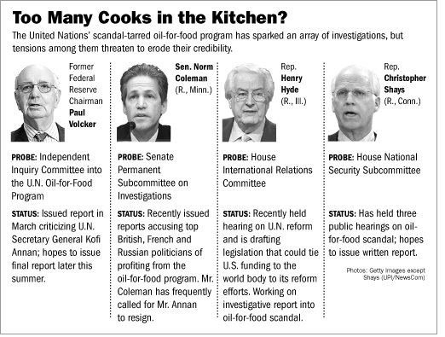
The two panels sharply differ about both Mr. Annan's personal culpability and the degree of access lawmakers should be given to U.N. documents and personnel as part of the congressional probes. At a recent hearing on U.N. reform, for example, Republican Rep. Ted Poe of Texas compared the oil-for-food program to bankrupt energy company Enron Corp. and said Mr. Annan should step down. "I believe there should be consequences," he said at the hearing.
The bad feelings between the two investigations began to flare last year when lawmakers tried to compel several senior U.N. officials to testify under oath but were rebuffed by officials of the world body, who said such access was unnecessary because of the Volcker probe. In November, Sen. Norm Coleman, the Minnesota Republican who is leading the Senate investigation, sent a letter to Mr. Annan that accused Mr. Volcker of hindering his probe by "affirmatively preventing the subcommittee" from obtaining key documents.
The Volcker panel was infuriated this year when internal U.N. audits the panel turned over to Congress were quickly leaked by lawmakers, forcing the panel to release them publicly earlier than planned.
Reid Morden, Mr. Volcker's chief of staff, said tensions were perhaps inevitable because of the inherent differences between a U.S. governmental investigation and an international one authorized by the U.N. and the entire Security Council.
"We've got a certain mandate we're trying to fulfill, and we try not to do anything to compromise the integrity of the investigation," Mr. Morden says. "Congress has its own responsibilities and its own interests, and there's not necessarily a great deal of linkage."
The latest chapter in this standoff was sparked last month when two of Mr. Volcker's investigators -- including the chief, Robert Parton -- left the panel shortly after it released a report chiding Mr. Annan's management lapses but clearing him of serious wrongdoing.
Mr. Parton, a former member of the Federal Bureau of Investigation's elite Hostage Rescue Team, resigned from his post April 12 without making any public comment. Nine days later, Mark Pieth, one of the Volcker panel's three commissioners, said in an interview with the Associated Press that Mr. Parton left because of disagreements with the panel's conclusions.
The following day, Mr. Parton was watching television at his home in Virginia when a second Volcker commissioner, Richard Goldstone, said on CNN that Mr. Parton had left solely because his work for the panel had been completed. Mr. Parton then issued a short public statement saying he resigned "not because my work was complete but on principle."
The Volcker panel responded by publicly accusing Mr. Parton of, in effect, stealing internal documents. That led Mr. Parton to issue a second public statement, which said his resignation from the Volcker panel stemmed from "concerns that the investigative process and conclusions were flawed."
Neither of Mr. Parton's statements gave any details of his complaints. He isn't speaking to the news media and declined several requests for comment for this article.
People familiar with the dispute say Mr. Parton was upset that Mr. Volcker and the panel's two other commissioners had refused to include additional evidence critical of Mr. Annan in their March report, despite the investigators' beliefs it met the panel's standards for inclusion. These people said the documents Mr. Parton retained when he left the panel included earlier drafts of the Volcker report that were more directly critical of the U.N. secretary general.
Mr. Parton turned copies of the documents over to one of the three congressional committees probing the oil-for-food scandal after lawmakers rebuffed Mr. Volcker's requests that they withdraw subpoenas compelling Mr. Parton's cooperation. That led Mr. Volcker to take the unusual step of asking the U.N. to seek a federal court order preventing Mr. Parton from handing the documents over to the two other congressional committees. A temporary order was issued May 9. Negotiators from the Volcker panel and the congressional committees are negotiating to end the standoff over Mr. Parton, but no deal is in sight. Indeed, the lawmakers who got Parton documents refuse to return them, and Senate leaders still are demanding the files.
Mr. Parton, meanwhile, has hired prominent Washington lawyer Lanny Davis, who was a crisis manager in the Clinton administration, to defend him publicly and handle the delicate legal negotiations with Congress and the Volcker panel. "He feels that he's really been dragged into something against his will. If anyone thinks he's this publicity hound out to embarrass Volcker and the secretary-general, that's just not true," Mr. Davis says.
Mr. Parton's home address was published in court documents due to an apparent oversight, causing him to fear for his safety, and he has watched uncomfortably as former colleagues on the Volcker panel accuse of him of stealing documents that could endanger witnesses and jeopardize its investigation.
"He just doesn't understand why he hasn't been allowed to go quietly into the night," Mr. Davis says.

