U.N. Security Council Expansion Is Not in the U.S. Interest
by Nile Gardiner, Ph.D., and Brett D. Schaefer
August 18, 2005

In the next few months, the United Nations General Assembly is expected to consider several proposals to expand the U.N. Security Council from the current 15 members—five permanent members (China, France, Russia, the United Kingdom, and the United States) and 10 non-permanent members elected to two-year terms. ^{[1]} There are several plans under consideration:
- The most discussed proposal is sponsored by Germany, Japan, India, and Brazil—the so-called Group of Four (G-4) nations aspiring to permanent membership on the Security Council. This plan would expand the Security Council from 15 to 25 members by adding six permanent members without veto power (one for each of the G-4 nations and two for Africa) and four non-permanent seats elected for two-year terms. ^{[2]} The G-4 plan is supported by the U.K. and France, but strongly opposed by China.
- The second proposal is from the 53-nation African Union (AU) and calls for a 26-member Security Council. As with the G-4 plan, the AU plan would add six new permanent members, including two permanent seats for Africa. It differs from the G-4 plan in that it calls for an additional five non-permanent seats instead of four and insists that new permanent members possess the veto.
- A third proposal, advanced by the Uniting for Consensus (UFC) group, calls for adding 10 non-permanent members to the Security Council, who can be re-elected. Argentina, Canada, Italy, Mexico, Pakistan, South Korea, Spain, and Turkey are the most prominent supporters of this plan.
As an amendment to the U.N. Charter, a proposal to expand the Security Council must clear two key hurdles. First, it must be supported by a two-thirds majority of the General Assembly, or 128 nations. Second, it must be ratified by two-thirds of the General Assembly and all five current permanent members of the Security Council. Thus, the Council cannot be expanded without U.S. approval.
The Bush Administration has expressed its opposition to these proposals on two grounds. First, while the Administration has stated that it is open to a modest expansion of the Security Council, it does not support an expansion of 10 or 11 new members. Instead, the United States has formally backed Japan’s bid for permanent membership on the Security Council and has expressed a willingness to consider “two or so new permanent members and two or three additional nonpermanent seats, allocated by region, to expand the Council to 19 or 20.”^{[3]}
Second, the Administration believes that any vote on expansion should follow implementation of other, more urgent U.N. reforms.^{[4]} The U.S. has argued that management failures, corruption, and lack of transparency and accountability do far more to undermine the effectiveness and reputation of the U.N. than the composition of the Security Council and that these issues should be the immediate focus of reform discussions.
While the Administration’s statement that it will vote against Council expansion unless management issues are addressed is welcome, it should go further and work with Congress to state clearly that the U.S. opposes any expansion of the Security Council. The problems of the United Nations are myriad, but few if any would be resolved by expanding the Security Council. The Bush Administration has stated that expansion should only be considered if it does not impede the effectiveness of the Council.^{[5]} However, even a modest expansion of the Council fails that test because it would make the Council even more unwieldy, contribute to gridlock, dilute U.S. influence in the Council, and likely result in a Council less supportive of the United States on many key issues.^{[6]}
General Assembly Voting Records of Key Security Council Contenders
The voting records of the key Security Council contenders should be cause for concern to the Bush Administration as it considers expansion of the Council. Analysis of actual votes (not including consensus votes) in the General Assembly over a six-year period (1999 to 2004) reveals that five of the leading candidates voted against the United States more than 70 percent of the time.^{[7]}
Only Germany (55 percent) and Japan (50 percent) voted with the U.S. at least half of the time. Brazil, the only contender from Latin America, voted with the U.S. just 29 percent of the time, while India, often touted as a major future ally of the United States, voted with the United States just 20 percent of the time. The records of the three leading African contenders for Security Council seats are equally poor. Nigeria and South Africa voted with the U.S. just 25 percent of the time, while Egypt—a huge beneficiary of American aid—sided with the U.S. in only 18 percent of the votes.
Of 190 members of the General Assembly (not including the U.S.), Germany had the best record among Security Council candidates, ranking 12th in voting coincidence with the United States. Japan ranks a surprisingly low 41st, but is still ahead of any other major country in Asia. Brazil ranks 80th, while Nigeria, South Africa, and India rank 104th, 106th, and 149th, respectively. Egypt ranks very near the bottom at 168th, behind Sudan and just ahead of rogue regimes such as Libya, Burma, and Syria.
Significantly, support for U.S. voting positions in the General Assembly has fallen since 1999 (dramatically in some cases) for all the countries competing for Security Council seats. While Germany backed the United States in 70 percent of votes in 1999, it voted with the U.S. just 45 percent of the time in 2004. Similarly, Japanese support for U.S. voting positions fell from 63 percent in 1999 to 43 percent in 2004. In 2004, Brazil and Nigeria voted with the U.S. just 15 percent of the time, and South Africa voted with the U.S. only 11 percent of the time. In 1999, these three countries voted with the U.S. 39 percent, 35 percent, and 40 percent of the time, respectively. Egypt’s record was a pitifully low 8.5 percent in 2004 (down from 29 percent in 1999). India has consistently voted against U.S. positions over the past five years, voting in opposition to the U.S. 80 percent of the time in 2004 and 78 percent of the time in 1999.
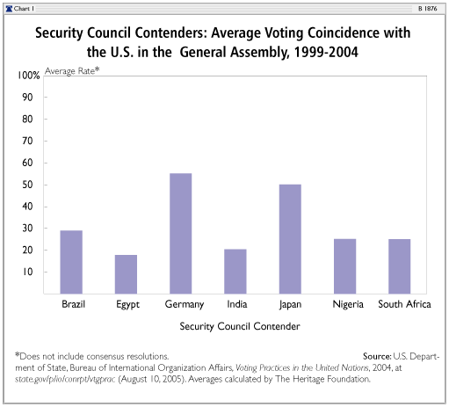
Voting Records on Key Issues
Every year the U.S. Department of State identifies votes of fundamental national interest in the U.N. General Assembly. Support for the U.S. voting position on key issues over the past five years among the key Security Council contenders has been low (Brazil, Nigeria, South Africa, India, and Egypt) to middling (Japan and Germany). South Africa and Nigeria voted against the U.S. position on key votes an average of 80 percent of the time between 2000 and 2004. India voted with the U.S. just 19 percent of the time, and Egypt just 16 percent. The Brazilian record was slightly better, voting with the U.S. 35 percent of the time. The U.S. did not receive a single vote of support from Nigeria, South Africa, India, or Egypt on any key vote in 2001. While the voting record of Germany and Japan is considerably stronger (Germany voted with the U.S. 64 percent of the time and Japan 66 percent of the time), their voting coincidence can hardly be considered reliable.
Worse than their actual voting records is the fact that these countries’ opposition to U.S. priorities is increasing. Germany, Japan, Brazil, South Africa, and Nigeria have sharply reduced their level of support for the U.S. on key votes since 1999. In 2004, Brazil, Nigeria, India, South Africa, and Egypt voted with the U.S. on just two key votes. Germany’s and Japan’s records were slightly better, voting with the U.S. on four votes.^{[8]}
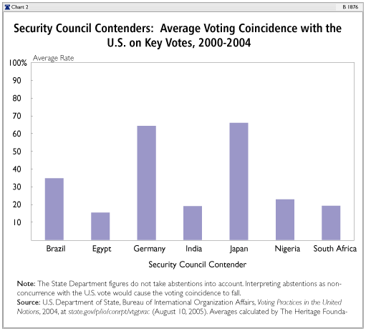
Their records speak for themselves. If these countries gain permanent seats on the Security Council, support for U.S. priorities would be unlikely to increase.
Key Recommendations
The effort to expand the Security Council suffered a serious blow when negotiations between the G-4 and the African Union to submit a joint proposal fell apart.^{[9]} Although neither proposal individually has the support of two-thirds of the General Assembly, a joint proposal would be more likely to meet that threshold.
The Bush Administration has gained a temporary reprieve due to the inability of the G-4 and the African Union to agree to a unified proposal, but the issue of Security Council expansion will continue to arise. The U.S. is not served by an ambiguous policy toward Security Council expansion, which leads other nations to believe that America could be persuaded to accede to expansion over time. To remedy this situation, the Administration and Congress should clarify America’s policy on Security Council by:
- Unambiguously announcing through public statements and a congressional resolution that the U.S. opposes the G-4, AU, and UFC proposals to expand the Security Council.
- Passing a joint resolution of Congress stating that any amendment to the U.N. Charter that alters the structure of the Security Council must be submitted to the Senate for advice and consent prior to ratification, as required by the U.S. Constitution. Further, the resolution should explain why expansion of the Council is not in the interest of the United States and that attempts to reform the Council without the advice and consent of the U.S. Senate risk damaging support for the institution in Congress— particularly financial support.^{[10]}
- Noting that, while inclusion of Japan on the Council is desirable, proposals to reform the Security Council should operate within its current size of 15.
Conclusion
The Bush Administration has correctly set increased effectiveness of the Security Council as the benchmark for Council reform. As the war on terrorism continues to unfold around the globe, as greater urgency is paid to limiting the spread of weapons of mass destruction, and as the free world faces a growing threat from rogue regimes such as Iran and North Korea, the U.N. Security Council can play an important and useful role. It is in the U.S. national interest to have a lean and effective Security Council that can help address these issues on the international stage. Unfortunately, the most prominent proposals to expand the Security Council will have the opposite effect.
Security Council expansion will make it far more difficult for the United States to work through the Council. With the exception of Germany and Japan, the voting records of the main contenders for additional permanent Security Council seats indicate that they will likely vote against the U.S. on most key issues. In other words, a larger Security Council with these nations as permanent members will likely be less supportive of U.S. policy priorities. Moreover, any enlargement of the Council would make it more unwieldy and subject to conflicting interests contributing to gridlock that will paralyze the Council and decrease the probability that it will act quickly or effectively to address threats to international peace and security.
The U.N. Security Council’s legitimacy depends far more on its actions than its membership. The Security Council is by no means perfect as it currently stands. It is subject to delay and indecisiveness, as its failures in Iraq and Sudan clearly demonstrate. However, a larger Council would not solve these problems. On the contrary, it would further undermine the Council’s ability to act decisively as timely action would fall victim to political impasse, conflicting interests, or debate among nations that have little to contribute to the Council’s ultimate responsibility—enforcement of international peace and security. However imperfect, the current composition of the Council is infinitely preferable to ill-considered expansion that will surely weaken its standing and ability to meet its mandate—ultimately making the Security Council less relevant and increasing the likelihood that crises will be addressed outside of the U.N. framework.
Nile Gardiner, Ph.D., is Fellow in Anglo–American Security Policy in the Douglas and Sarah Allison Center for Foreign Policy Studies, a division of the Kathryn and Shelby Cullom Davis Institute for International Studies, and Brett D. Schaefer is Jay Kingham Fellow in International Regulatory Affairs in the Center for International Trade and Economics at The Heritage Foundation. Heritage Research Associate Anthony Kim and Heritage Intern Sarah Liston contributed to research for this paper.

Appendix A
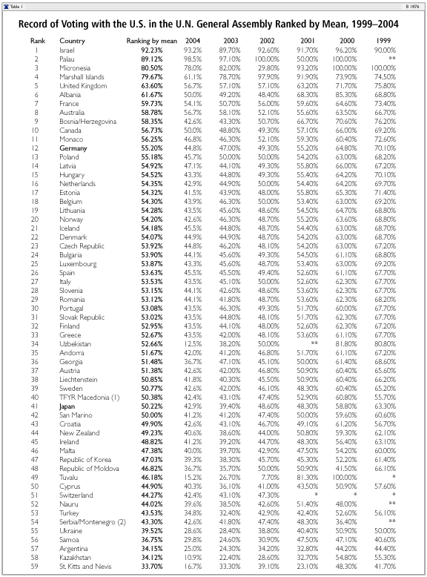

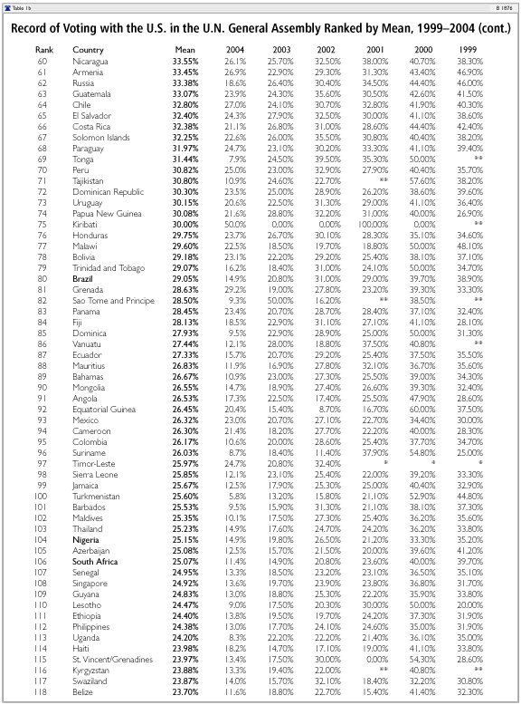

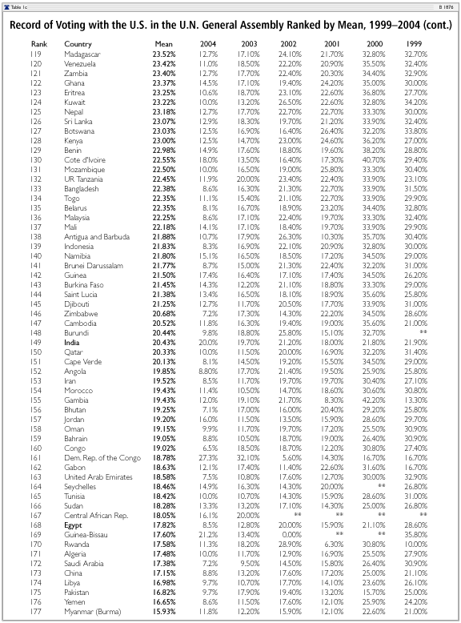

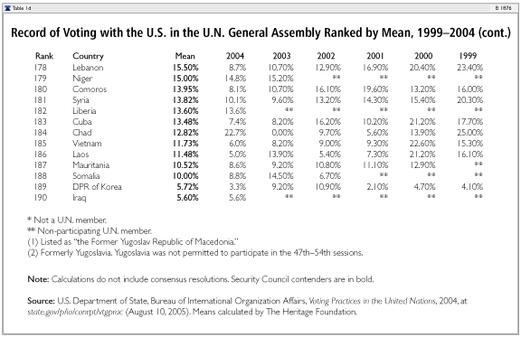

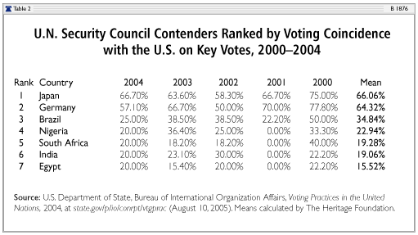

^{[1]}Secretary General Kofi Annan and advocates of Security Council expansion were hopeful that the General Assembly would vote on a proposal by September 2005, but the failure of any one proposal to elicit support from the necessary two-thirds of the General Assembly has made that goal unlikely. Annan has now announced that he hopes that the issue will be resolved by December 2005. See Edith M. Lederer, “Annan Extends Target for Council Expansion,” The Washington Post, August 10, 2005, at www.washingtonpost.com/wp-dyn/content/article/2005/08/10/AR2005081001908.html (August 12, 2005).

^{[2]}The six permanent slots would be taken by Germany, Japan, India, Brazil, and two African countries. The leading African contenders for permanent seats are Egypt, South Africa, and Nigeria.

^{[3]}Ambassador Anne Patterson, remarks to a closed meeting of the U.N. General Assembly, June 22, 2005, quoted in William M. Reilly, “U.S. Spells Out U.N. Reforms Sought,” United Press International, June 23, 2005.

^{[4]}The U.S. position was made clear in a statement by acting U.N. Ambassador Anne Patterson: “[The U.S. will] vote no on any proposal...that would expand the council without management reform and [establishing] the Human Rights Council.” Quoted in Betsy Pisik, “U.N. to Vote on Adding 11 to Security Council,” The Washington Times, July 28, 2005, at www. washingtontimes.com /world/
20050727-100104-2537r.htm (August 10, 2005).

^{[5]}See U.S. Department of State, “U.S. Priorities for a Stronger, More Effective United Nations,” June 17, 2005, at www.state.gov/ documents/organization/48439.pdf (August 10, 2005).

^{[6]}For a more detailed discussion, see Brett D. Schaefer, “The United States Should Oppose Expansion of the U.N. Security Council,” Heritage Foundation Backgrounder No. 1140, September 22, 1997, at www.heritage.org/Research/InternationalOrganizations/BG1140.cfm (August 12, 2005).

^{[7]}U.S. Department of State, Bureau of International Organization Affairs, Voting Practices in the United Nations, 2004, at state.gov/p/io/conrpt/vtgprac (August 10, 2005).

^{[8]}In 2004, the 10 key votes were: the U.S. Embargo of Cuba, Human Rights in Sudan, Committee on the Inalienable Rights of the Palestinian People, Division for the Palestinian Rights of the Secretariat, Fissile Material Cutoff Treaty, Work of the Special Committee to Investigate Israeli Practices, Elimination of all Forms of Religious Intolerance, Enhancing the Role of Organizations to Promote Democracy, Human Rights in Iran, and International Trade and Development.

^{[9]}In July and early August 2005, the G-4 and the AU had engaged in intense negotiations to forge a consensus proposal for Security Council expansion. Such a compromise to merge the two competing proposals was deemed necessary to gain support from two-thirds of the General Assembly. A tentative compromise proposed increasing the Council by six permanent seats without the veto, and five non-permanent seats. However, the AU met and voted against supporting the compromise on August 4, 2005, and decided to press forward with its demand for the new permanent members to have the veto. See Reuters, “Africa Turns Down Compromise on U.N. Expansion,” Independent Online, August 5, 2005, at www.iol.co.za/ index.php?set_id=1&click_id=84&art_id=vn20050805063523423C706133 (August 10, 2005).

^{[10]}Article II, Section 2, Clause 2, of the U.S. Constitution states that the President “shall have the power, by and with the Advice and Consent of the Senate, to make Treaties, provided two thirds of the Senators present concur.” Articles 108 and 109 of the U.N. Charter state that adopting member states of the United Nations shall ratify any amendments to the Charter “in accordance with their respective constitutional processes.” Further, any change to the existing structure of the Security Council will, by its nature, require amending the U.N. Charter. Pursuant to the requirements of the U.S. Constitution and the Charter of the United Nations, the President is required to submit to the Senate for advice and consent any agreement that alters the existing structure of the United Nations Security Council, as occurred in 1965 when the Senate approved expansion of the Security Council from 11 countries to 15 by a vote of 71 to 0.

