A grim reckoning

October 27, 2005
The Economist
Original Source: http://www.economist.com/agenda/displaystory.cfm?story_id=5098266
The Volcker committee has issued its final report on the UN-administered oil-for-food programme in Iraq, and it makes for grim reading: kickbacks were paid in connection with the contracts of over 2,000 companies. National prosecutors may now take an interest
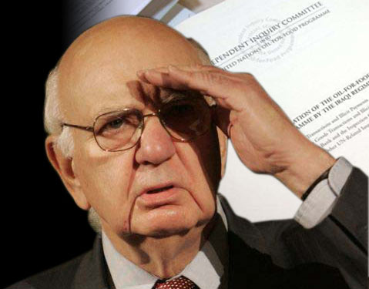
Volcker spies skulduggery

Get article background
IS THE scandal over the United Nations-administered oil-for-food programme for Iraq finally drawing to a close? On Thursday October 27th, a committee headed by Paul Volcker, a former chairman of the Federal Reserve, issued its fifth and final report on the affair. It claims that between 1997 and 2003, the Iraqi government sold $64 billion-worth of oil to 248 companies and bought $34.5 billion-worth of humanitarian goods. Oil “surcharges” totalling $229m were paid to Saddam Hussein’s regime in connection with the contracts of some 140 companies, the committee says; the humanitarian kickbacks reached $1.5 billion and were paid in connection with the contracts of 2,253 firms.
But perhaps most explosively, the report names hundreds of names, both of individuals who were allegedly given valuable oil allocations to sell, and companies that allegedly went along with the various schemes. Mr Volcker’s work may now be done, but as he has frequently noted, his committee has no judicial power. The work of national prosecutors may be just beginning.
One of Saddam’s schemes involved awarding allocations of oil to individuals and organisations that Iraq believed would support its case politically. These allocations could then be sold on to oil traders or companies who would take possession of the oil. The surcharges paid by the oil companies would go to Saddam’s government, with a chosen intermediary making a profit by selling his allocation at a mark-up.
Of those listed, the largest number are from other Arab countries. But several prominent Europeans appear as well. Many communist and left-wing parties from the former eastern bloc, including in Ukraine, Russia and Belarus, appear on the list of beneficiaries. So do Charles Pasqua, a former interior minister of France, Vladimir Zhirinovsky, the head of the far-right Liberal Democratic Party in Russia, and George Galloway, a British member of parliament who, having been kicked out of the Labour Party, now represents the anti-war and leftist Respect party in the House of Commons. Mr Galloway and Mr Pasqua responded with letters denying the allegations, which are included in the report.
Mr Galloway in particular has become a symbol of the affair, largely for his outspoken opposition to the Iraq war and for his subsequent public confrontation with America’s Senate. Mr Galloway testified before the Senate Permanent Subcommittee on Investigations in May, strenuously denying having benefited from oil-for-food and, while he was at it, excoriating America’s leaders for deceiving the world in their quest to make war on Iraq. This week, just before Mr Volcker’s report, the Senate subcommittee issued one of its own with much the same conclusions, that Mr Galloway had received oil allocations from Iraq. Both Mr Volcker and the Senate are basing their conclusions on documents from the Iraqi oil ministry, as well as on testimony from former Iraqi officials in custody. Mr Galloway has responded with a statement that, given what is known about the treatment of American detainees, such testimony is worthless.
Mr Volcker’s report also casts a harsh light on the many companies involved in the mess. The report stresses that many of the firms concerned may not have known about the illegal payments. But it does accuse four international oil-trading companies of “coalescing to dominate” the Iraqi oil market during the final years of Saddam’s regime by dint of paying the surcharges. The four firms—Bayoil Supply & Trading Limited (from the Bahamas), Glencore International (Switzerland), the Vitol Group (the Netherlands) and the Taurus Group (New Zealand)—employed intermediaries to purchase about 60% of Iraqi oil from December 2000 until Saddam’s fall in 2003. All four firms have denied knowingly paying the fees.
Last week, federal prosecutors charged Oscar Wyatt, a veteran Texan oilman, with conspiring with David Chalmers, the owner of Bayoil (USA) Inc, the parent of the Bahamas firm, to bribe Saddam’s government to obtain oil. Mr Chalmers was indicted in April. Both men have denied the charges. Last month, Vladimir Kuznetsov, a Russian former official in the UN’s procurement office, was also charged in connection with the oil-for-food scandal, while in France, Jean-Bernard Mérimée, a former French ambassador to the UN, has been formally placed under investigation on suspicion of having received oil-for-food kickbacks.
There is scant good news in the report for the UN (whose former head of the oil-for-food programme, Benon Sevan, was accused of taking kickbacks in a previous Volcker report). But there is at least a chink of light for the organisation. Though several people involved in the scandal were acquainted with or related to Boutros Boutros-Ghali, a former UN secretary-general, the committee found no evidence that he himself was involved. It also cleared two “humanitarian co-ordinators” employed by the world body in Iraq of any violations of UN ethics.
But the document will nonetheless provide more fuel for those who say that the UN needs root-and-branch reform. John Bolton, America’s ambassador to the UN, stressed this message after receiving the report. He noted that Saddam was only able to get away with it “with the willing co-operation of UN officials, the acquiescence of some member states, and, as today's report indicates, the willingness of private companies and individuals”. Some would point the finger back at America, noting that the UN Security Council had responsibility for overseeing oil-for-food contracts but was too busy worrying about weapons of mass destruction to fret about corruption. Nonetheless, the final Volcker report is another blow to the embattled UN. Whether it will result in any meaningful reform is still an open question.

