Barbara Kay on the Anti-Semitism and tyranny of Durban II: France's intellectuals are following Stephen Harper's lead

By Barbara Kay
February 29, 2008
National Post
Original Source: http://network.nationalpost.com/np/blogs/fullcomment/archive/2008/02/29/barbara-kay-on-the-anti-semitism-and-tyranny-of-durban-ii-france-s-intellectuals-are-following-stephen-harper-s-lead.aspx
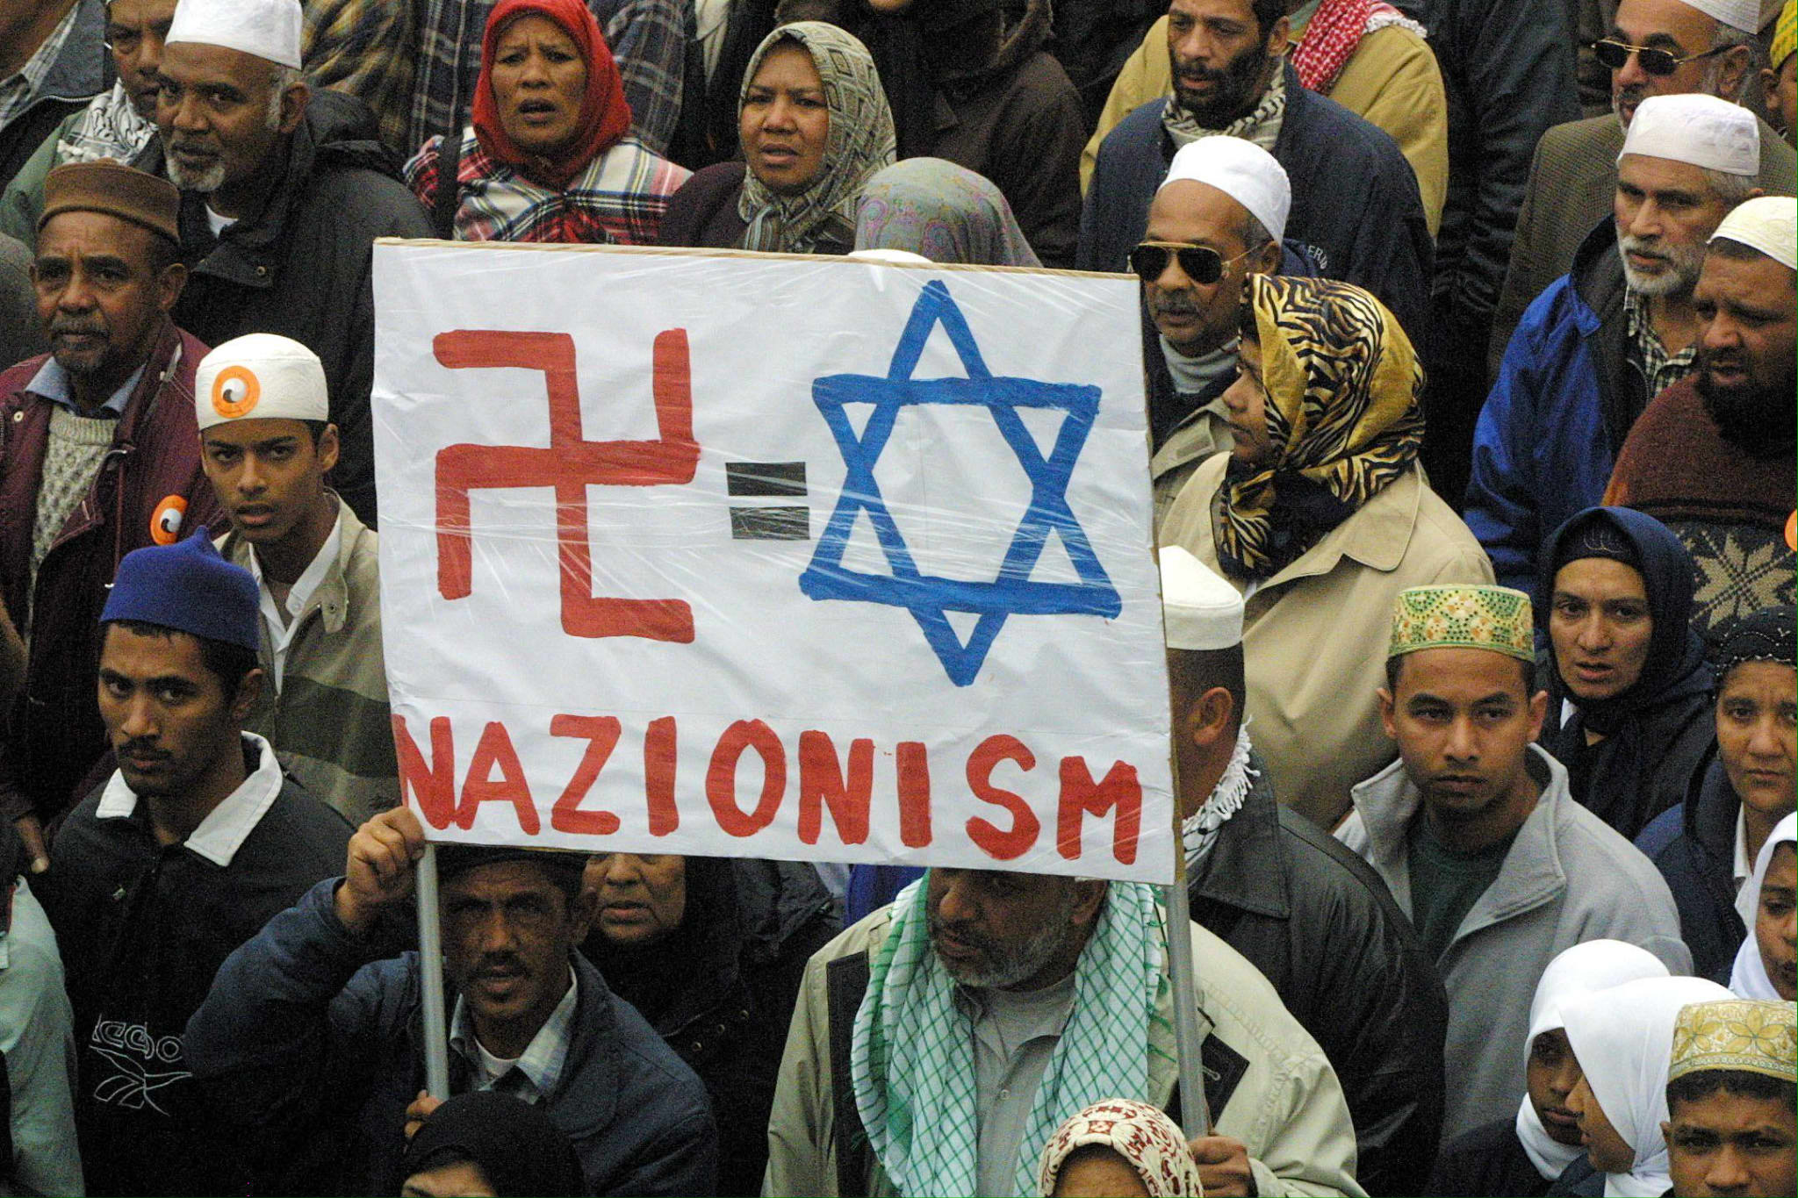
If for nothing else he ever did or will do, Stephen Harper put Canada on the map for integrity and leadership when he announced that Canada would not take part in the 2009 anti-racism “conference” known as Durban II. It is already obvious that the 2009 version will be a replay and worse of the original moral and political travesty, which even in its planning stages had already plunged into a morass of anti-western and anti-Semitic vituperation.
Harper’s decision is having a motivational ripple effect. On Feb. 27, a petition was sent to Le Monde in France, signed by many of France’s intellectual and aesthetic icons, such as Alan Finkielkraut, Claude Lanzmann and Elie Wiesel, to cite a few universally recognized and respected names.
The letter explodes with moral indignation: “At Durban, in South Africa, the global conference against racism was held under the auspices of the United Nations, in the very city where Gandhi began his career as a lawyer. It is in the name of human rights that “Death to America” and “Death to Israel” was chanted; and it is in the name of cultural relativism that there was silence on the discrimination and violence committed against women.”
The letter is densely packed with criticisms of the coalitions and alliances that have helped collapse the once noble idea of the universality of human rights into the nefarious “Declaration of the Rights of Man” (the declaration that UN High Commissioner of Human Rights Louise Arbour recently approved but was later forced to recant due to its assertion that Zionism is racism), which holds up for approval “new norms” and terminology that “annuls freedom of expression, legitimates the oppression of women and stigmatizes western democracies.”
The letter is quite detailed, and will no doubt soon be published in an official translation, but it is rather inspiring: “The great political crimes have always needed words to lend themselves legitimacy. Words presage action. From Mein Kampf ... to Stalin to Pol Pot, examples abound that justify the necessary extermination of the people’s enemy in the name of a race, in the name of the workers’ emancipation or in the name of some divine spiritual order. Totalitarian ideologues have replaced religions. … On September 11, 2001, several days after the Durban conference, it was in God’s name that the worst terrorist crime in history was committed.”
The letter condemns the passivity of the Western democracies in the face of such “strategies.” The authors adduce as examples of those who have been persecuted for refusing to submit to religious obscurantism Ayaan Hirsi Ali, Salman Rushdie, Robert Redeker (the French teacher who was forced into hiding for criticizing Islam) and asks: “What is the price of their liberty?”
The global stakes are clear, the authors say. Either we defend individual liberties or we give in to "a radical perversion of our whole tradition of battling against racism, which could in the past and can only in the future develop with the most absolute freedom of conscience.”
In the final paragraph, the authors conclude that “Either democracies get their act together, following Canada's example, who just announced its refusal to participate in Durban II, recognizing that it risked being 'marked by expressions of intolerance and anti-Semitism,' and cease to abstain from or vote for resolutions contrary to the universal ideal of 1948, or religious obscurantism and its trail of political crimes will triumph under the good auspices of the United Nations. And when the hateful words are transformed into acts, nobody will be able to say: 'We didn’t know.'"
You can read the original letter and sign the petition at:
http://www.lemonde.fr/opinions/article/2008/02/27/l-onu-contre-les-droits-de-l-homme_1016249_3232.html
[PHOTO: A protest in Cape Town in 2001 just ahead of the Durban World Conference Against Racism. AFP / Getty Images.]

