UN Human Rights Council
Working Group of Experts on People of African Descent
Thirteenth Session on the Intergovernmental Working Group on the Effective Implementation of the Durban Declaration and the Programme of Action (IGWC)
Geneva, 5 – 16, October 2015
Palais des Nations, Conference Room XXI

Racial Discrimination and Poverty in Colombia
Executive Summary
Carlos Augusto Viáfara López
Associate Professor in the Department of Economics at the Universidad del Valle, Cali - Colombia
carlos.viafara@correounivalle.edu.co
(First Draft, October 5th 2015)
(Do not cite)

Introduction
Poverty is considered one of the worst scourges of humanity. For many people, the main challenge of development policies is eradicating it, which was reflected in the Millennium Development Goals (MDGs) and the new Sustainable Development Goals (SDGs). One of the most significant stylized facts about poverty in Latin America, after including the ethnic-racial approach in the 2000 round of censuses and other household and quality of life surveys, has been the discovery that ethnic-racial groups have a high incidence in poverty.

In Colombia, some researchers have purported to explain the high rates of poverty in afrodescendant population through their overrepresentation in marginalized regions, like the Pacific or the Atlantic coast, or through their settlement in the slums that surround big cities, which determines lower human capital endowments. However, there has been little research on the factors that led to these results for afrodescendant population. Racism and racial discrimination in various areas may have a decisive effect in explaining why the black population is overrepresented among the poorest in society.

The aim of this paper is to analyze the mechanisms associated with racism and racial discrimination that determine the highest rates of poverty faced by afrodescendant people in Colombia.

What is poverty?
There are two main approaches about poverty: a) as a lack of income or consumption, which does not allow people to meet their socially defined basic needs or b) as a lack of basic capabilities. Referring to the first view, National and International Poverty and Indigence Lines (PL-IL) have been the most widely used methodology. The second one has favored the construction of synthetic indices that account the multidimensional nature of poverty, such as the Multidimensional Poverty Index (MPI), which nowadays is the most widely used poverty index.

Incidence of poverty for afrodescendant population in Cali
Figure 1, panel A, shows the percentage of people living in poverty and extreme poverty, according to the per capita household income, by ethnic-racial group in Cali. The gaps in the rates of poverty and extreme poverty between afrodescendants and whites reached 61.1% and 126.3%, respectively. As can be seen, the incidence of poverty and extreme poverty increases monotonically as the skin color of heads of household becomes darker. From another perspective, panel b shows the percentage of poor population according to the capabilities approach. It is important to mention that although the percentage of people living in poverty decreased considerably, the ethnic-racial hierarchy was reproduced as in the estimations of monetary poverty. The gap between white and afrodescendant people in poverty rate, according to the MPI, was 52.6%.

Figure 1
Percentage of people in poverty by ethnic-racial group in Cali
a. Poverty headcount index  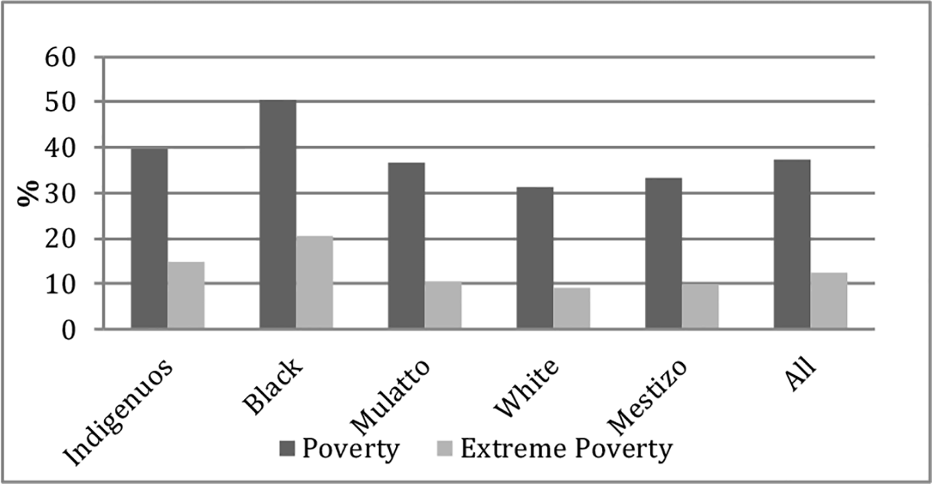 | b. Multidimensional poverty index  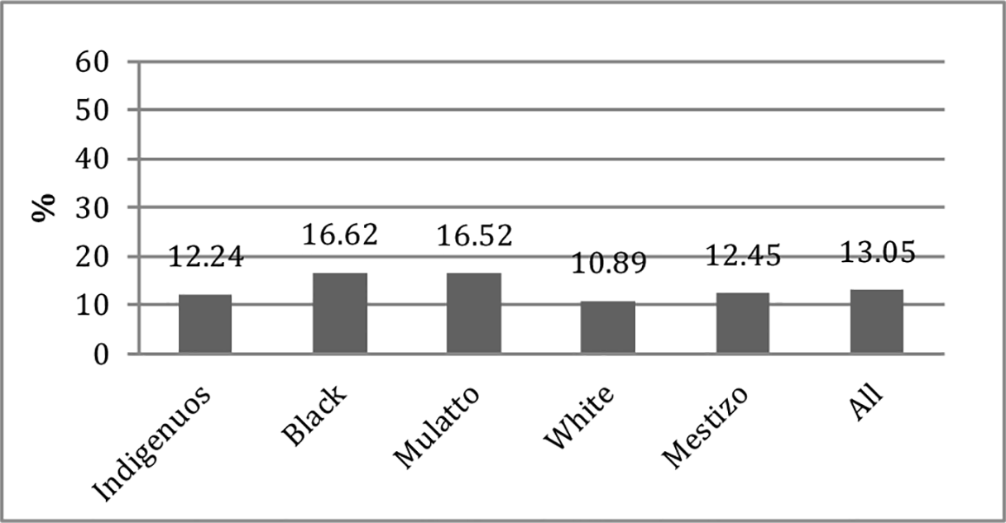
Source: EECV-Cali 2012-2013. Estimations by the CIDSE

Can education explain the lower revenue of afrodescendant population?

The methodology used here does not allow separating the effects of the ethnic-racial status from other variables that influence the poverty rate among households. This means we cannot know how much of the differentials in the poverty rate among households, according to their ethnic-racial status, can be attributed to gaps in education (premarket discrimination) or to the direct effect of the ethnic-racial condition (market discrimination).

It is evident that the background discussion is whether the ethnic-racial status should be considered in the estimation of welfare indicators for afrodescendant population in Colombia, which is in contrast to the myth that Latin American societies are racial democracies only because of the existence of miscegenation. To answer this question, it is important to analyze how the ethnic-racial status affects working income. This means that if people in the labor market are treated in an unequal and unjust way, they will get lower wages than their non-afrodescendant counterparts. The low wages in turn result from a mismatch of income that situates afrodescendants among the poorest people in society and restricts their development of capacities that could enable them to overcome these situations.

For this purpose, regression models of specific race were estimated for disaggregating the ethnic-racial differences in income. The included control variables were education, experience, experience squared and the inverse Mills ratio (to correct potential selection bias). The results allow concluding that the average income gap, for individuals with the same characteristics, between afrodescendant and white people reached 27.9%. This disaggregation suggests that 44.9% of these income differentials is explained by human capital gaps between afrodescendant and whites (premarket discrimination), while the rest, about 55.1%, remains to be explained and could be associated with market discrimination (see Table 1).

From the above discussion, two main conclusions can be drawn. First, there is an important effect of variables associated with human capital on the income differential between afrodescendant and white population. Second, the unexplained component, which is usually related to discrimination, is strong and significant for explaining wage gaps.

Table 1
Disaggregation of incomes between afrodescendant and white population
 | Afrodescendant Vs White
 | Total difference |  | Endowments |  | Remuneration |  | Residuals
Average | 0,279 | 100% | 0,125 | 44,90% | 0,145 | 52,10% | 0,008 | 3,00%
Sd | 0,09 | 100% | -0,007 | -8,80% | 0,07 | 78,00% | 0,027 | 30,80%
P10 | 0,223 | 100% | 0,172 | 77,20% | -0,008 | -3,80% | 0,059 | 26,60%
P25 | 0,169 | 100% | 0,13 | 77,00% | 0,104 | 61,50% | -0,065 | -38,50%
P50 | 0,115 | 100% | 0,06 | 52,20% | 0,093 | 81,10% | -0,038 | -33,30%
P75 | 0,387 | 100% | 0,224 | 57,90% | 0,195 | 50,40% | -0,032 | -8,30%
P90 | 0,471 | 100% | 0,189 | 40,30% | 0,284 | 60,30% | -0,002 | -0,60%
Source: constructed by the CIDSE with data from the EECV – Cali.

Conclusions and Policy Recommendations
If the ethnic-racial status is an important factor in explaining inequalities between afrodescendants and non-afrodescendants, only the implementation of policies of affirmative action or positive differentiation can improve the quality of life of the poorest Afro-Colombian and indigenous people. In addition, this kind of policies will encourage processes of upward social mobility for those who made great efforts to invest in human capital.

Regarding the latter, special or inclusion policies should be aimed at eliminating the deprivations that limit the effective enjoyment of human rights and fundamental freedoms on an equal basis. In line with the recommendations of the United Nations, during the International Decade for People of African Descent, five core policies are proposed:

- Inclusion policies to promote greater accumulation of quality human capital for afrodescendant population. This implies eliminating premarket discrimination against afrodescendants, in such way that they can improve their skills and compete on equal terms for positions of higher socioeconomic status, which is the basic principle of all meritocratic society.
- Inclusion policies in the labor market for improving the employability of afrodescendant population.
- Inclusion policies for encouraging entrepreneurship and supporting productive initiatives from afrodescendant population, as an important alternative to overcome poverty.
- Inclusion policies to encourage and to strengthen productive clusters where afrodescendants have comparative advantages, drawn from their cultural particularities. This means, entrepreneurial supporting to micro, small and medium enterprises, which are based on their cultural frameworks, for generating income, employment and welfare.
- Social inclusion policies to strengthen public institutions to be transparent and efficient. The aim is to ensure a differential approach in information systems and their adjustment in order to monitor and to measure the impact of inclusion policies.

Economist. Master in Population Studies. Director of the Center for Socioeconomic Research and Documentation (CIDSE) of the Universidad del Valle. Member of the research group: "Ethnic-racial studies and work in their different social components”.

